Solution Requirements

Functional Requirements

FR No | Functional Requirement
FR-01 | The system shall allow users to create and manage Insurance Policy records for Vehicle, Property, and Life Insurance.

FR-02 | The system shall support separate Record Types for Vehicle, Property, and Life policies.
FR-03 | The system shall capture product-specific policy information such as VIN for Vehicle Insurance and Square Footage/Year Built for Property Insurance.
FR-04 | The system shall provide a guided Auto Quoting Screen Flow to capture policy holder, policy start date, state, VIN, and model year.
FR-05 | The system shall create a draft policy during the quoting process.
FR-06 | The system shall calculate policy premiums using Apex-based premium calculation logic.
FR-07 | The system shall validate Vehicle Insurance VINs and ensure that the VIN contains exactly 17 characters.
FR-08 | The system shall allow users to create and manage Claim records associated with policies.
FR-09 | The system shall support different Claim Record Types for Accident, Property, and Life claims.
FR-10 | The system shall automatically route claims to the appropriate queue based on the related policy type.
FR-11 | The system shall identify high-value claims based on the configured claim amount threshold.
FR-12 | The system shall submit qualifying high-value claims through a multi-level approval process involving Senior Adjusters and Claims Managers.
FR-13 | The system shall provide an Approve/Reject Claim capability with approver comments.
FR-14 | The system shall provide Claims Adjusters with an LWC Claims Dashboard showing assigned claims.

FR-15 | The dashboard shall display information such as Claim Number, Policy Type, Policy Holder, Claim Amount, Status, and Days Open.
FR-16 | The dashboard shall allow users to filter claims by All, Auto, Property, and Life.
FR-17 | The system shall provide automated updates to related Policy and Claim records through Record-Triggered Flows.
FR-18 | The system shall support state-based access/sharing for applicable insurance users and records.
FR-19 | The system shall provide role-specific access through Permission Sets for Insurance Agents, Claims Adjusters, and Claims Managers.
FR-20 | The system shall support reporting and visibility of Customer, Policy, and Claim information from the centralized Salesforce platform.

Non-Functional Requirements

The following requirements describe the expected quality, usability, security, scalability, and maintainability of the solution. Some are derived requirements based on the project's stated objectives and challenges rather than explicitly documented as formal NFRs.

ID | Non-Functional Requirement | Description
NFR-01 | Usability | The system should provide simple, guided Screen Flows that minimize unnecessary clicks and make policy quoting easy for agents.
NFR-02 | Performance | Policy quoting, premium calculation, claim routing, and dashboard operations should execute efficiently to support day-to-day insurance operations.

ID | Non-Functional Requirement | Description
NFR-03 | Scalability | The solution should support the three insurance lines—Vehicle, Property, and Life—and allow additional insurance products to be accommodated in the future.
NFR-04 | Data Integrity | Policy and claim information should be validated to maintain accurate and consistent data across insurance products.
NFR-05 | Security | Access to insurance information should be controlled according to the user's responsibility, including state-based sharing and role-specific Permission Sets.
NFR-06 | Maintainability | The solution should use modular Salesforce components such as Flows, Apex classes, LWC components, Record Types, and Field Sets so that individual components can be maintained independently.
NFR-07 | Reliability | Automated claim routing, premium calculation, and approval processes should consistently execute according to the configured business rules.
NFR-08 | Extensibility | The data model should accommodate different product-specific fields without requiring completely separate structures for each insurance line.
NFR-09 | Visibility | Users should have timely access to relevant Customer, Policy, and Claim information through centralized Salesforce records and the Claims Dashboard.
NFR-10 | User Adoption | The application should provide an intuitive experience that reduces manual effort and supports efficient adoption by agents and claims users.

Data Flow Diagram
Flow:
Customer / Agent → Screen Flow → Policy Validation → Policy c → PremiumCalculator → Claim c → Claim Routing Flow → Claims Queue → Claims Adjuster → Approval Process → Claim Update → LWC Dashboard / Reports

Main Data Flow
Step 1 – Customer / Agent Input
→ Customer and policy information is provided by the Insurance Agent. Step 2 – Policy Data Capture
→ AutoQuoting Screen Flow captures policy holder, policy start date, state, VIN, and model year.
Step 3 – Policy Validation
→ Salesforce validates the entered information, including the 17-character VIN requirement for Auto policies.
Step 4 – Policy Creation
→ Valid information is stored in the Policy c object with the appropriate Vehicle, Property, or Life Record Type.
Step 5 – Premium Calculation
→ Policy information is passed to PremiumCalculator Apex to calculate the applicable premium.
Step 6 – Claim Creation
→ When a claim occurs, the user creates a Claim c record linked to the relevant Policy. Step 7 – Claim Routing
→ A Record-Triggered Flow identifies the policy type and routes the claim to the appropriate Auto, Property, or Life Claims Queue.
Step 8 – Claim Review
→ The Claims Adjuster accesses assigned claims through the Claims Dashboard and reviews policy and claim information.
Step 9 – High-Value Claim Approval
→ Claims exceeding the configured threshold are submitted for approval to the Senior Adjuster → Claims Manager.
Step 10 – Claim Decision & Update
→ The approver selects Approve/Reject and provides comments; the claim status is updated.
Step 11 – Dashboard & Reporting
→ Claim information is displayed through the LWC Claims Dashboard, providing visibility into claim amount, policy type, policy holder, status, and days open.
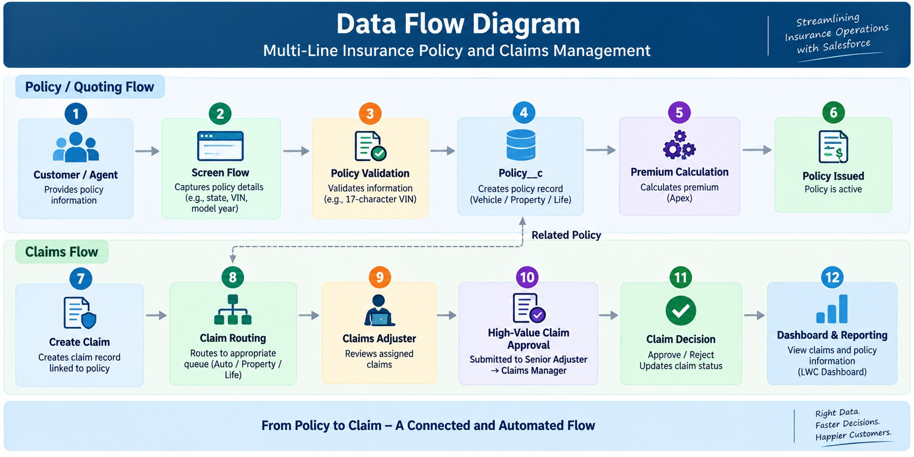

Technology Stack

Layer | Technology
UI | Salesforce Lightning, Lightning Web Components (LWC)
Logic | Salesforce Flows, Apex
Database | Salesforce Custom Objects (Policy c, Claim c), Contact, User
Automation | Record-Triggered Flows, Validation Rules, Approval Processes
Processing | Apex Premium Calculator, Apex Controllers
Data Configuration | Record Types, Field Sets, Custom Fields
Security | Permission Sets, State-Based Sharing Rules
Reporting | Salesforce Reports & Dashboards
Testing | Apex Test Classes

